**NOTE: This is an official document by Indexademics. Unless otherwise stated, this document may not be accredited to individuals or groups other than the club IDX, nor should this document be distributed, sold, or modified for personal use in any way.**

**IDX G9 Chemistry H STUDY GUIDE ISSUE 6**

**By Hayley and Allison**

8.4 Bond Polarity and Electronegativity

Polarity of the Bond

- **Polarity** refers to a separation of positive and negative charge.

- **Bond Polarity**: a measure of how equally or unequally the electrons in any covalent bond are shared.

- **Nonpolar covalent bond** is one in which the **electrons are shared equally**, as in Cl2 & N2

- In a **polar covalent bond, electrons are shared unequally**, one of the atoms exerts a greater attraction for the bonding electrons than the other

- Element with greater electronegativity has greater attractive force in chemical bonding.

- If the difference in relative ability to attract electrons (electronegativity) is large enough, an ionic bond is formed

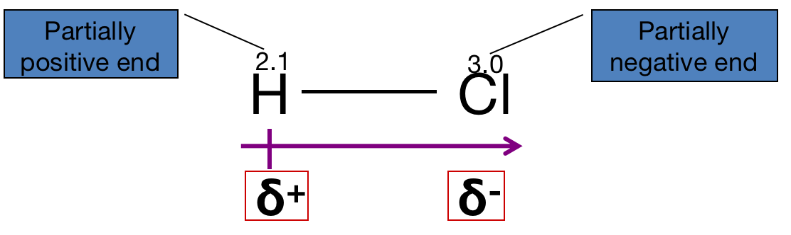

Bond Type By Electronegativity

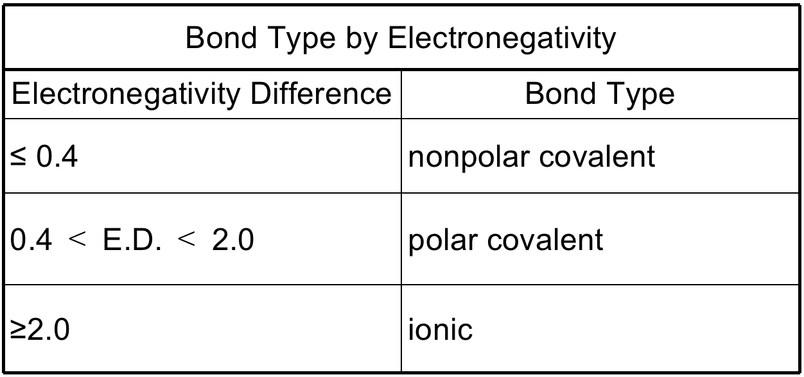

Dipole moments (Polarity of molecule)

- Molecular polarity is dependent on **bond polarity** and the **molecular geometry**.

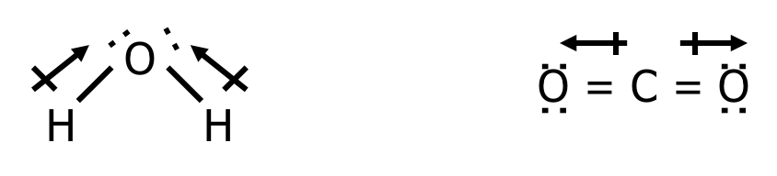 - E.g. Water is a polar molecule, but carbon dioxide is not

- **Polar Molecule (dipole)**– A molecule has one end with a positive charge and another end with a negative charge.

- **Nonpolar Molecule** – A molecule that does not have positive or negative ends.

For a simple molecule

- A molecule only contains nonpolar bonds is usually nonpolar (exception: O3 polar molecule)

- If it contains **polar bond** and the **molecular shape is symmetrical** (positive and negative charge center at the same place), it is nonpolar molecule.

- A polar molecule usually contain **polar bonds** and an **asymmetrical structure**

8.5 Drawing Lewis Structures

* Molecular formula: shows all the numbers of atoms in one molecule, i.e. NH3 (g)
* Structural formula: uses letter symbols and bonds to show relative positions for atoms, AKA Lewis structures.

Writing Lewis Structures

1. Sum valence electrons
2. Identify central atom
3. Complete octets of surrounding atoms
4. Place leftover electrons in central atom
5. If central atom’s octet is not fulfilled, add bonds. If there are leftover atoms after completing all octets, put them around the central atom (d-orbital, can be more than 8 electrons)
6. Add the charge if it’s an ion

Examples

ClO4- 🡪 7 + 6*4 + 1 = 32 electrons = 16 pairs

CO32- 🡪 4 + 3*6 + 2 = 24 electrons = 12 pairs

OCl2 🡪 6 + 7*2 = 20 electrons = 10 pairs

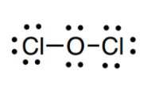

BrCl3 🡪 7 + 7*3 = 28 electrons = 14 pairs

Other Structures

* Molecular geometry: showing the arrangement in a 3D form of the structure

Example

PBr3 🡪 trigonal pyramidal

✩ nonbonded electrons repel more than bonded electrons, affecting the molecular geometry

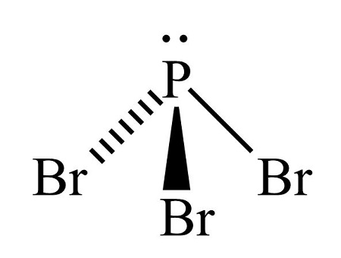

Formal Charge

* Used to find the best Lewis structure, which is the one that
  + Has the fewest charges (as close to zero as possible)
  + Puts a negative charge on the most electronegative atom
* Valence electrons – (bonding electrons/2) – non-bonding electrons

Example

